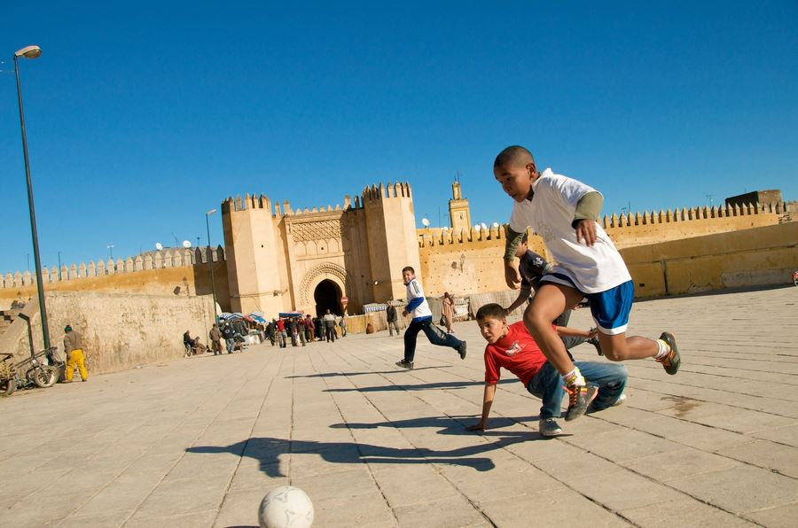
According to a Pew Research Center report conducted in 2009, Muslims make up more than 1/5th of the world’s population, almost 1.6 billion people. Muslims are born, live, eat, work, study, play, worship and die on almost every continent and numerous island nations. Yet US discussions about Islam and Muslims often describe the faith as monolithic, unchanging, and the people as following the same practices. Muslim leaders and texts describe Muslims as belonging to a boundary-erasing nation (‘ummah). Yet many recognize differences and divisions based in practices and beliefs, ascribing these to local cultures and global ideological influences. Islam and Muslim culture are discussed and used as rationale for events in US media and public talk daily.

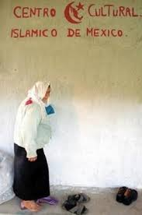
What does it mean to argue that Islamic practices and Muslim culture are the reason for events that make the news (and even those that don’t)? How do we make sense of these arguments about the relationships between belief, culture, and action? How do Muslims move through the world, engage the many opinions circulating around them, employ religious texts (or not), and interact with non-Muslims? Is there Muslim culture(s) or is this a concept used for political and social domination and/or discrimination?

This course offers anthropological perspectives on these questions.

Some of the themes we will explore include:

Lived experiences of Islam
Politics of Muslim diaspora(s)
Social lives of Islamic texts and media Islam
Ethnicity, Race and Islam
Leisure, consumption and morality

INTENDED LEARNING OUTCOMES
The key goals of this class are:
- To gain a deeper knowledge of the human complexity and richness of Islam
- To enhance your understanding of ethnography as a writing genre and analytical method
- To learn how to critically engage theories and texts about Muslim communities and practices
- To expand your research, analysis, writing, and oral presentation skills
This course will fulfill three of the anthropology department’s learning goals:
- Students are able to demonstrate proficiency in the use critical thinking skills.
- Students are able to demonstrate proficiency using current methods in their major fields, including library research skills.
- Students are able to express themselves knowledgably and proficiently in speaking about central issues in their major field.

COURSE ASSIGNMENTS
The course will involve a mix of readings, class discussion, films, guest speakers and the following assignments: reading question posts (20 points), field observation assignments (20 points), 2 video essays (40 points each).

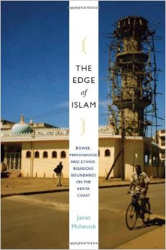
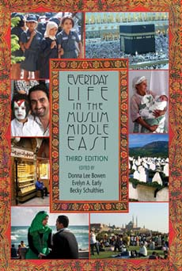
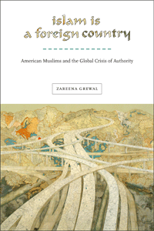
KEY TEXTS
- Bowen, Donna Lee, Evelyn Early and Becky Schulthies. 2014. Everyday Life in the Muslim Middle East, 3rd Edition. Bloomington, IN: Indiana University Press.
- Grewal, Zareena. 2013. Islam is a Foreign Country: American Muslims and the Global Crisis of Authority. New York: NYU Press.
- McIntosh, Janet. 2010. The Edge of Islam: Power, Personhood, and Ethnoreligious Boundaries on the Kenya Coast. Chapel Hill, NC: Duke University Press.
- Readings on Sakai

COURSE EXPECTATIONS

Because this is an upper-level course, the reading load is heavy, and the expectations I have of your performance will be high. On average, you should expect to put in two to three hours of work outside of class for every hour of in-class time. You are expected to complete the assigned readings before class, to attend all class meetings, and to come prepared to actively engage with course material by thinking critically and creatively about the assigned texts and the issues they raise. Regular attendance is required, and you will be expected to come to class having completed all of the reading and ready to participate in class discussions whenever possible. In fact, class participation and attendance will comprise a significant portion of your grade. If you expect to miss one or two classes, please use the University absence reporting website https://sims.rutgers.edu/ssra/ to indicate the date and reason for your absence. An email is automatically sent to me. In cases where you must miss class for periods longer than one week, you will as per university policy be directed to see a Dean of Students for assistance to help verify these circumstances. If you are a person who does not readily participate in large groups, I encourage you to come see me during my office hours, and we can devise other ways for you to have input into class discussions.
Since for many of you the material will be somewhat unfamiliar, it might appear quite difficult at first. In particular, you’ll have to get used to a fair amount of technical terminology. We will go over definitions in class, and things should get easier as you become more accustomed to the language, style of argument, and intellectual issues in the readings. Please bring questions on material that you do not understand to class or to my office hours. The only “bad” questions are the ones that you don’t ask.
On occasion, there will be films screened in class. If you miss the in-class screening, please make arrangements to view the materials in the library. All assignments must be completed in order to pass the course. The dates and material in this syllabus may be subject to change, so listen carefully to announcements in class, and check Sakai frequently for changes or cancellations.

Please note also the following policies:
- Late submission is not accepted without prior permission of the instructor.
- Online Assignment Submission: For ease of reference and grading, include your name in the beginning of your document title when you submit on Sakai. For example: Schulthies Semiotic Observation ANTH 108.doc
- Special arrangements for students with documented needs or disabilities should be made well in advance of assignment due-dates. Follow the policies outlined here http://disabilityservices.rutgers.edu/ and discuss this with me as soon as possible.

Rutgers Policies: Please make yourself aware of the student code of conduct, especially the academic code of conduct. http://studentconduct.rutgers.edu/university-code-of-student-conduct
Plagiarism: In preparing assignments a student often needs or is required to employ outside sources of information or opinion. All such sources should be listed in the bibliography. Citations and footnote references are required for all specific facts that are not common knowledge and about which there is not general agreement. New discoveries or debatable opinions must be credited to the source, with specific references to edition and page even when the student restates the matter in his or her own words. Word-for-word inclusion of any part of someone else’s written or oral sentence, even if only a phrase or sentence, requires citation in quotation marks and use of the appropriate conventions for attribution. Please follow the American Anthropological Association style guide in the bibliography and in-text referencing. Paraphrasing or summarizing the contents of another’s work is not dishonest if the source or sources are clearly identified (author, title, edition, and page), but such paraphrasing does not constitute independent work and may be rejected by the instructor. Students who have questions about accurate and proper citation methods are expected to consult Rutgers’ policies on plagiarism.

SCHEDULE

Date | Assignments | Date | Assignments
Sept 1 | Pew Research Center. 2009. Mapping the Global Muslim Population: A report on the size and distribution of the World’s Muslim Population, 1-26 (it’s all maps and charts).  Optional:  Marranci, Gabrielle. 2008. The Anthropology of Islam. New York: Berg, 31-50.  Varisco, Daniel. 2005. Islam Obscured: The Rhetoric of Anthropological Representation. Palgrave McMillan, 139-145.  Bowen, John R. A New Anthropology of Islam. Malden MA: Cambridge University Press, 1-10.  Asad, T. 1986. The Idea of An Anthropology of Islam. Occasional Paper Series Center for Contemporary Arab Studies, Washington, DC: Georgetown University Press, 1-7.  Said, Edward 1997 Covering Islam. Pantheon Books, 3-32. | Sept 4 | Marranci, Gabrielle. 2008. The Anthropology of Islam. New York: Berg, 12-30.  Bowen, Donna Lee, Evelyn Early and Becky Schulthies. 2014. Everyday Life in the Muslim Middle East, 3rd Edition. Bloomington, IN: Indiana University Press, 4-5, 303-309.  Hafez, Sherine. 2013. Will the Rational Religious Subject Please Stand Up? Muslim Subjects and the Analytics of Religion. In Anthropology of the Middle East and North Africa: Into the Millennium, Sherine Hafez and Susan Slyomovics, eds. Bloomington, IN: Indiana University Press, 187-201
Sept 8 | Monday Classes | Sept 11  Piety and Practice | Bowen, John R. A New Anthropology of Islam. Malden MA: Cambridge University Press, 42-74.  AND  Bowen, Donna Lee. 2014. Abu Illya and Zakat. In ELMME3, 315-318  Optional: Schielke, Samuli. 2009. Being Good in Ramadan: Ambivalence, Fragmentation, and the Moral Self in the Lives of Young Egyptians. Man: Journal of the Royal Anthropological Institute (N.S.): S24-40.
Sept 15  Soundscape | Nelson, Kristina. 2014. The Sound of the Divine in Daily Life. In ELMME3, 310-314.  AND  Sells, Michael. 2000. Approaching the Quran. White Cloud Press, 145-157  Optional:  Khan, Naveeda. 2011. The Acoustics of Muslim Striving: Loudspeaker Use in Ritual Practice in Pakistan. Comparative Studies in Society and History 53(3):571-594. | Sept 18  Pilgrimage  1st observation assignment due | Betteridge, Anne. 2014. “Caught among the Unbelievers”: How Pilgrimage Shapes Iranians’  Understandings of Sectarian Difference. In ELMME3, 362-372.  Bianchi, Robert. 2014. The Hajj in Everyday Life. In ELMME3, 319-328.  Inside Mecca
Sept 22  Eyad Rituals (Religious Holidays)  Sept 23—Eid al-Adha | Bowen, Donna Lee. 2014. Abdul Qadar and the Sheep of ʿAid al- Adha. In ELMME3, 329-330.  Roberts, Sean R. 2007. Everyday Negotiations of Islam in Central Asia: Practicing Religion in the Uyghur Neighborhood of Zarya Vostoka in Almaty, Kazakhstan. In Everyday Life in Central Asia, Jeff Sahadeo and Russell Zanca, eds. Bloomington IN: Indiana University Press, 339-354. | Sept 25  Eyad  Rituals (Religious Holidays) | Korom, Frank and Peter Chelkowski. 1994. Community process and the performance of Muharram observances in Trinidad. The Drama Review 38(2): 150-170.  Skim the first 3 pages and conclusion of:  Kambar, Kabir. 2011. Iterations of lament: Anachronism and affect in a Shi‘i Islamic revival in Turkey. American Ethnologist 38(3):484-500.  Hosay Trinidad
Sept 29 | O’Connor, Paul 2012. Islam in Hong Kong: Muslims and Everyday Life in China’s World City. Hong Kong University Press, 97-113.  Uighur food?  Silverstein, Brian. 2014. Sufism and Everyday Ethics in Turkey. In Everyday Life in the Muslim Middle East, 3rd Edition, Donna Lee Bowen, Evelyn Early, and Becky Schulthies, eds. Bloomington, IN: Indiana University Press, 351-361.  http://www.zabihah.com/sub/United-States/New-Jersey/Central-Jersey/vr8UY9Iinp | Oct 2 | Khan, Naveeda. 2010. “Mosque Construction, Or the Violence of the Ordinary” Beyond Crisis: Reevaluating Pakistan, Routledge, 482-512.  Flueckiger, Joyce Burkhalter. 2009. Amma’s Healing Room: Gender and Vernacular Islam in South India. Bloomington, IN: Indiana University Press, 1-5, 168-200.  Nada guest visit
Oct 6  2nd observation assignment due | Agrama, Hussein Ali. 2010. Ethics, tradition, authority: Toward an anthropology of the fatwa. American Ethnologist 37(1): 2–18.  OR  Messick, Brinkley. Sharia Ethnography or Radio Mufti | Oct 9 | Inhorn, Marcia. 2014. Middle Eastern Masculinities in the Age of Assisted Reproductive Technologies. In ELMME3, 143-150.  OR  Hamdy, Sherine. 2014. Kidneys, Kinship, and Muslim Ethics in Egypt. In ELMME3, 69-84.  OR  Ghannem, Farha. 2014. Contested Traditions: Gender and Mourning Practices in Egypt. In ELMME3, 85-95.  OR  Wynn, Lisa. 2013. Hymenoplasty and the relationship between doctors and muftis in Egypt. In Islam in Practice, Gabriele Marranci, ed. New York: Routledge, 34-48.  OR  Beeman, William. 2014. Few “Gays” in the Middle East, but Significant Same- Sex Sexuality. In ELMME3, 151-158.  OR  Mir- Hosseini, Ziba. 2014. Tamkin: Stories from a Family Court in Iran. In ELMME3, 172-184.  (films Inside Out and Tamkin)
Oct 13  Oct 15—Muharram | First Video Essay Due  Applying Sharia | Oct 16  Video Essay Paper Due | Grewal, Zareena. 2013. Islam is a Foreign Country: American Muslims and the Global Crisis of Authority. New York: NYU Press, 1-26
Oct 20 | Grewal, Zareena. 2013. Islam is a Foreign Country: American Muslims and the Global Crisis of Authority. New York: NYU Press, 31-78 | Oct 23  Ashura | Grewal, Zareena. 2013. Islam is a Foreign Country: American Muslims and the Global Crisis of Authority. New York: NYU Press, 79-124
Oct 27 | Grewal, Zareena. 2013. Islam is a Foreign Country: American Muslims and the Global Crisis of Authority. New York: NYU Press, 125-173 | Oct 30 | Grewal, Zareena. 2013. Islam is a Foreign Country: American Muslims and the Global Crisis of Authority. New York: NYU Press, 177-218  Optional: Early, Evelyn. 2014. Tele-Preachers and Talk Shows: Egyptian Religious Discourse, ELMME3, 331-350.
Nov 3 | Grewal, Zareena. 2013. Islam is a Foreign Country: American Muslims and the Global Crisis of Authority. New York: NYU Press, 219-252  Skim:  Adely, Fida. 2014. Pedagogy, Islamic Education, and Life Lessons in a Jordanian Secondary School for Girls. In ELMME3, 282-292.  Veiled Voices clips | Nov 6 | Grewal, Zareena. 2013. Islam is a Foreign Country: American Muslims and the Global Crisis of Authority. New York: NYU Press, 292-356
Nov 10 | McIntosh, Janet. 2010. The Edge of Islam: Power, Personhood, and Ethnoreligious Boundaries on the Kenya Coast. Chapel Hill, NC: Duke University Press, 1-43 | Nov 13 | McIntosh, Janet. 2010. The Edge of Islam: Power, Personhood, and Ethnoreligious Boundaries on the Kenya Coast. Chapel Hill, NC: Duke University Press, 45-87
Nov 17 | McIntosh, Janet. 2010. The Edge of Islam: Power, Personhood, and Ethnoreligious Boundaries on the Kenya Coast. Chapel Hill, NC: Duke University Press, 127-175 | Nov 20  AAA Denver | McIntosh, Janet. 2010. The Edge of Islam: Power, Personhood, and Ethnoreligious Boundaries on the Kenya Coast. Chapel Hill, NC: Duke University Press, 177-220.  Watch film: Edge of Islam
Nov 24 | McIntosh, Janet. 2010. The Edge of Islam: Power, Personhood, and Ethnoreligious Boundaries on the Kenya Coast. Chapel Hill, NC: Duke University Press, 221-261 | Nov 25 | Wednesday as Friday
Dec 1 | Video Essay Two Due  Authority, Race/Ethnicity, and Authenticity | Dec 4 | Abu-Lughod, Lila  2002 Do Muslim Women Really Need Saving? Anthropological Reflections on Cultural Relativism and Its Others. American Anthropologist 104 (3): 783–790  AND  Jaschok, Maria and Hau Ming Vicky Chan. 2009. Education, Gender and Islam in China: The place of religious education in challenging and sustaining ‘undisputed traditions’ among Chinese Muslim women. International Journal of Educational Development 29:487–494  Nutter El-Ouardani, Christine. 2014. Childhood and Development in Rural Morocco: Cultivating Reason and Strength. In ELMME3, 24-38.  Chatty, Dawn. 2014. Harasiis Marriage, Divorce, and Companionship, In ELMME3, 49-54.  White, Jenny. 2014. Two Weddings. In ELMME3, 55-68.  Frield, Erika. 2014. A Thorny Side of Marriage in Iran. In ELMME3, 122-132.  Jensen, Natalie. 2014. The “Ramallah Girls”: Social Change in Urban Space. In ELMME3, 159-171.
Dec 8 | Wiktorowicz, Quintan. 2014. Islamist Activism in Jordan. In ELMME3, 224-234.  Fontan, Victoria. 2014. Democracy’s Collateral Damage. In ELMME3, 235-244.  Shehata, Samer. 2014. Politics of Class on an Egyptian Factory Floor. In ELMME3, 245-263.  McGlinchey, Eric M. 2007. Divided Faith: Trapped between State and Islam in Uzbekistan. In Everyday Life in Central Asia, Jeff Sahadeo and Russell Zanca, eds. Bloomington IN: Indiana University Press, 305-308.

- Bowen, John R. A New Anthropology of Islam. Cambridge University Press.
- Bowen, John R. Can Islam be French?
- Korom, Frank. Taziyah in Trinidad
- Salat by mahmood
- Islamic anthro by Akbar Ahmed
- Said
- Engseng Ho on genealogies
- Asad
- Islamic finance?
- Hirschkind hearing and modernity
- Leisurely islam deeb and harb
- Jaschok women’s mosques in China
- O’Connor Halal food in Hong Kong
- Ways of being Malay and Muslim
- Naveeda Khan? Matthew Hull?
- Tapper on Islamic anthropology?

